BILL OF LADING (NON NEGOTIABLE)
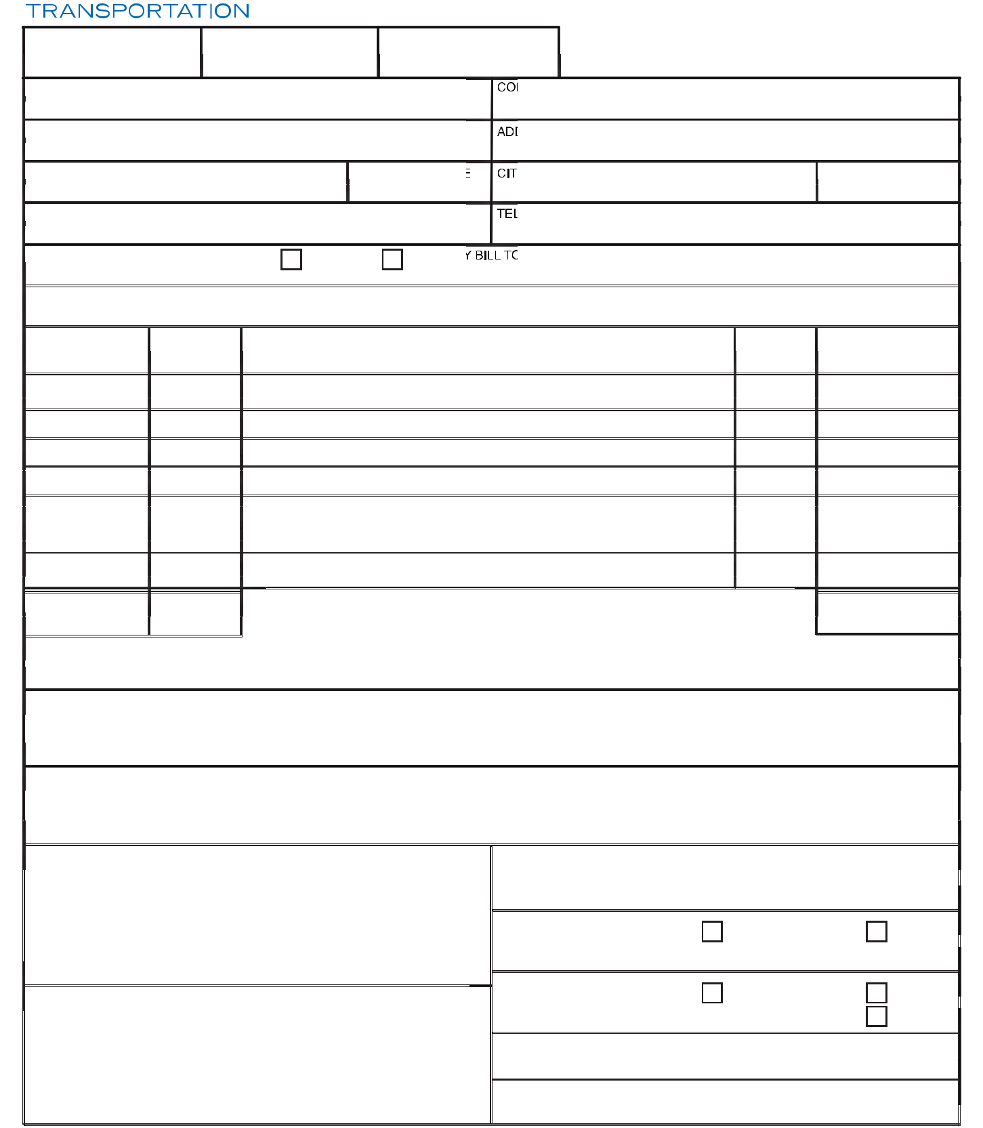

DATE | SHIPPER'S NO. | CSA TRACKING NO.
SHIPPER |  | CONSIGNEE

ADDRESS | ADDRESS

CITY, STATE / PROVINCE | ZIP / POSTAL CODE | CITY, STATE / PROVINCE | ZIP / POSTAL CODE
TELEPHONE |  | TELEPHONE

FREIGHT CHARGES WILL BE COLLECT |  |  | PREPAID | 3RD PARTY BILL TO:
UNLESS MARKED OTHERWISE
CUSTOMS BROKER:
NO. OF HANDLING | NO. OF |  |  | DESCRIPTION OF ARTICLES | CLASS |  | WEIGHT
UNITS | PIECES |  |  | MARKS AND EXCEPTIONS |  |  | (SUBJECT TO
(PALLETS/CRATES) |  |  |  |  |  |  | INSPECTION)

TOTAL UNITS | TOTAL PCS.

DECLARED VALUATION: $___________________________

TOTAL WEIGHT

NOTE: Pursuant to item 510 of CSA’s Terms and Conditions our legal liability limit does not exceed $4.41 per kilogram or $2.00 per pound under any condition. If a higher valuation is required CSA must be notified in advance and an additional charge may apply.

This shipment is subject to the terms and conditions found online at www.csatransportation.com and shall apply unless other specific agreements are reached and agreed to in writing and signed by a CSA Transportation manager authorized to do so. The shipper hereby certifies that he is familiar with the terms and conditions document at www.csatransportation.com and the same terms and conditions are hereby agreed to by the shipper and accepted for himself and his assigns.

CSA agrees to carry this shipment to its final destination under the terms and conditions of this Bill of Lading

NOTE: This space is reserved for shippers specific request or special agreement between shipper and CSA

 | All shipments are subject to CSA terms and conditions available at: |  |  |  |  |  | DRIVER USE ONLY
 |  | www.csatransportation.com
 | 6KLSSHU &RQWDFW :_________________________________________________ |  |  |  |  |  | CSA TRACKING NO.:
 | SIGNATURE:_________________________________________________ |  |  |  |  |  | Pieces Counted |  | Yes | No (Said To Contain)
 | DATE:_________________________________________________ |  |  |  |  |  | # of pieces:_________
 |  |  |  |  |  |  | Pallets Counted |  | Yes | No (Said To Contain)
 | &RQVLJQHH&RQWDFW:_______________________________________________ |  |  |  |  |  | # of pallets:_________ |  |  | Shrink Wrapped Pallet
 |  |  |  |  |  |  | Freight Conditions or Exceptions:
 | SIGNATURE:_______________________________________________
 |  | FREIGHT RECEIVED IN APPARENT GOOD ORDER (EXCEPT AS NOTED)
 |  |  |  |  |  |  | Driver: |  |  | Date:
 |  | DATE:_______________________________________________
 | VANCOUVER | CALGARY | EDMONTON | TORONTO | MONTREAL |  | NEW YORK | DALLAS | LOS ANGELES |  | SAN FRANCISCO | SEATTLE
T 604.214.0006 |  | T 403.279.0555 | T 7. | T 416.754.0999 | T 514.631.8893 |  | T 347.394.7437 | T 817.527.2350 | T 562.483.8780 |  | T 510.265.5535 | T 253.218.0799
 | F 604.214.0008 | F 403.279.0577 | F 403.279.0577 | F 416.292.5217 | F 514.631.4548 |  | F 347.394.7436 | F 817.527.2355 | F 562.483.8781 |  | F 510.265.5545 | F 253.218.0797

www.csatransportation.com

