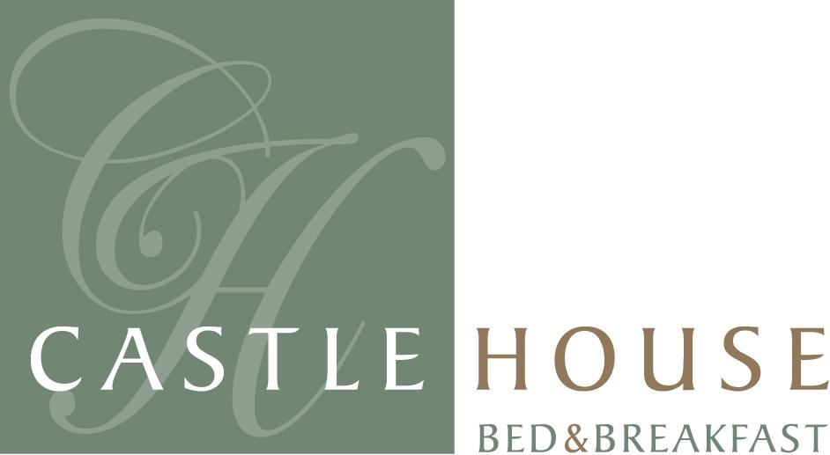

Castle House B&B Tel : 01745 816 860
Bull Lane Mobile : 07834 207 991
Denbigh Fax : 01745 817 214
Denbighshire Email Stay@CastleHouseBandB.co.uk
LL16 3SN www.CastleHouseBandB.co.uk
VAT Number 932 5610 37

Voucher Number WEB-001

GIFT VOUCHER FOR A STAY AT THE 5 * CASTLE HOUSE B&B

Complementary Spa access to Springs-Spa included. A full range of extra treatments are available, which need to be pre booked in advance.

Mr. & Mrs. John Smith have sent you this Gift Voucher for a two night stay at Castle House B&B, Denbigh. To book your choice of date of stay, please contact Charlie or Angie at Castle House quoting the voucher number at top of this page to reserve your chosen date.
For Spa Treatments visit www.Springs-Spa.co.uk

Minimum stay of 2 nights on Fridays and Saturdays apply in June, July August

