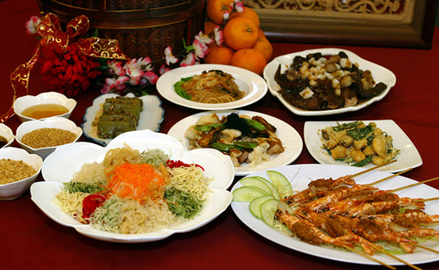

**Breakfast**

Juice…………………………………………………………………………………… ½ cup  
Refined cooked cereal………………………………………………………… ½ cup  
Eggs or lean meat…………………………………………………………… 2 or 2 OZ  
White toast……………………………………………………………………….. 2 slices  
Butter or margarine……………………………………………………………..2 pats  
Jelly………………………………………………………………………….…. As Desired  
Milk……………………………………………………………………………………… 8 OZ  
Decaffeinated coffee……………………………………………………… if tolerated

**Lunch or Supper**

Cream soup…………………………………………………………….….. 3/4th cup  
Bland vegetables………………………………………………….………….. ½ cup  
Salad……………………………………………………………………………. 1 portion  
White bread or Roll……………………………..………………………………….. 1  
Bland dessert or fruit………………………….………………………… 1 portion  
Milk………………………………………………..……………………………………. 8 OZ

Menu

**Restaurant Name**