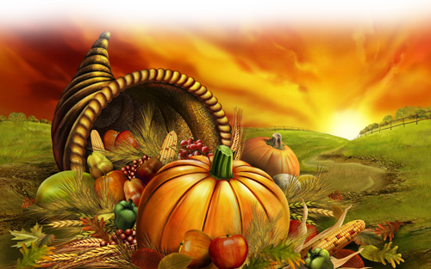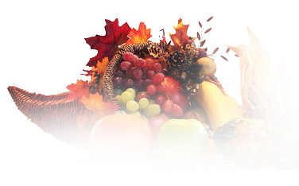

***Name of resto***

Appetizers

Cranberry Chutney

Devilled Eggs

Spinach Dip

Main Course

Turkey

Mashed Potatoes

Gravy

Soy Glazed Green Beans with Bacon

Roasted Asparagus

Caramelized Onion and Apple Stuffing

Roasted Sweet Potatoes with Pecan Crumb Topping

Dinner Rolls with Whipped Butter

Dessert

Apple Pie

Pumpkin Pie

Cherry Pie

Chocolate Cream Pie

Menu Template