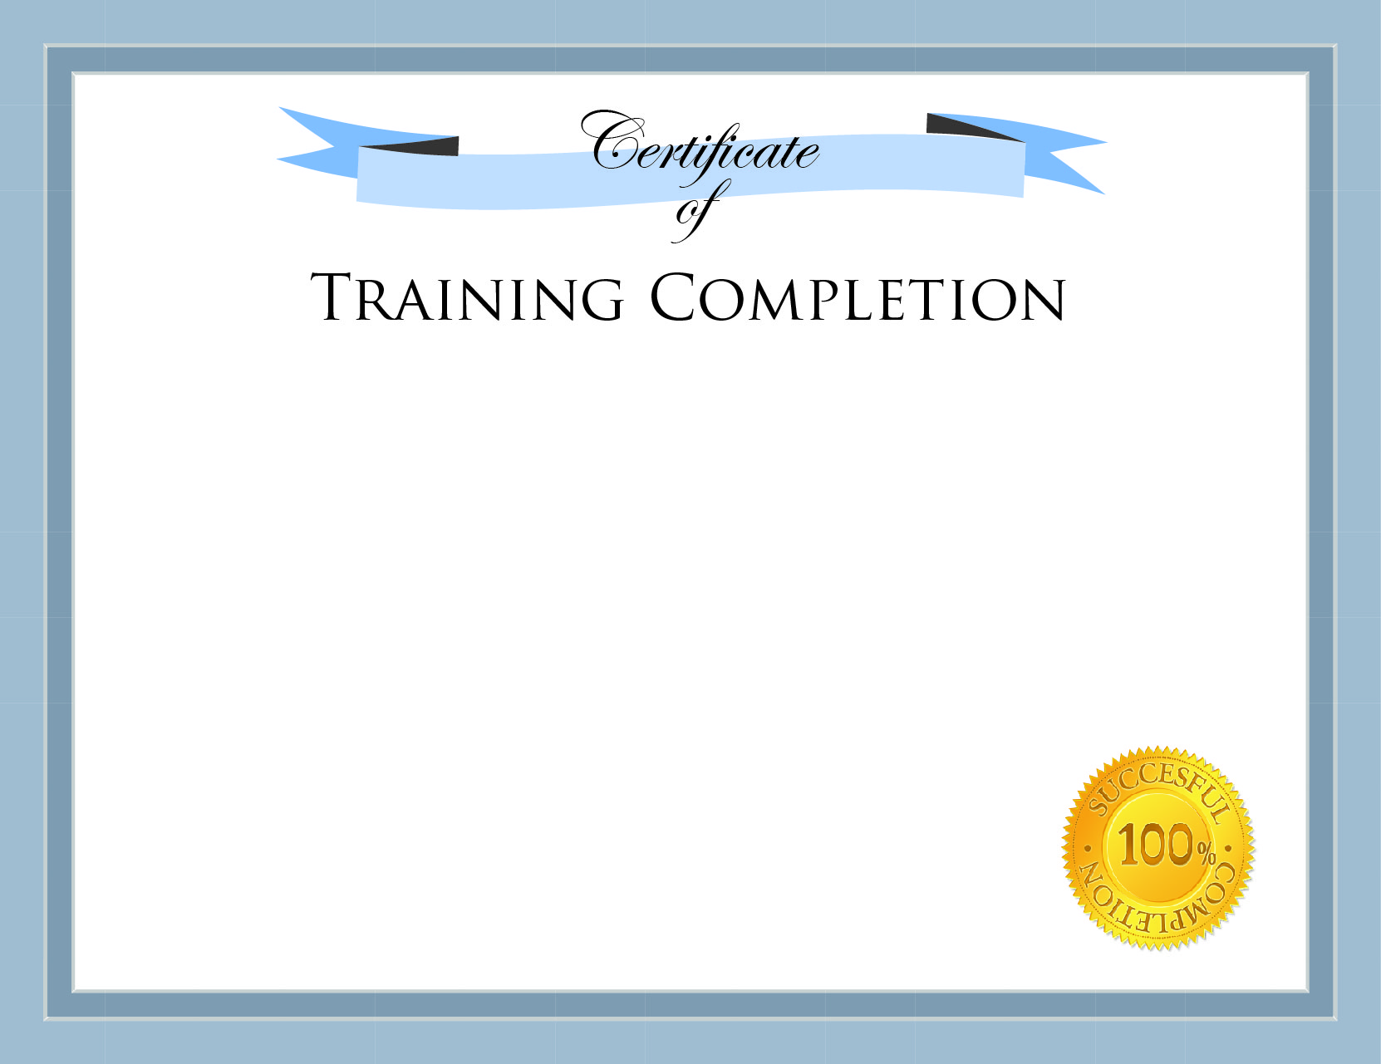
Instructor
This certifies that

Richard Thompson

has successfully completed the training in

PHP Programmer Level II

On December 31, 2012
Robert D. Robertson

